ORACLE SQL SESSIONS ASSIGNMENT -03

1.

select *from(

select dense_rank () over(order by dor.order_total desc) as ranks,

dc.customer_id,

dc.cust_first_name,

dc.cust_last_name,

dc.cust_city,

ds.state_name,

dc.phone_number1,

dor.order_total

from demo_states ds

inner join demo_customers dc on ds.st=dc.cust_state

inner join demo_orders dor on dc.customer_id=dor.customer_id

)

where ranks<=3;

2.

select *from(

SELECT

dense_RANK() OVER (ORDER BY orders_count DESC) AS rank,

customer_id,

orders_count,

cust_first_name,

cust_last_name,

cust_city,

state_name,

phone_number1

FROM (

SELECT

DISTINCT dc.customer_id,

COUNT(*) OVER (PARTITION BY dc.customer_id) AS orders_count,

dc.cust_first_name,

dc.cust_last_name,

dc.cust_city,

ds.state_name,

dc.phone_number1

FROM demo_states ds

INNER JOIN demo_customers dc ON ds.st = dc.cust_state

INNER JOIN demo_orders dor ON dc.customer_id = dor.customer_id

))

fetch first 3 rows only;

3.

select

dense_rank() over(order by total_quantity desc) rank,

product_id,

product_name,

product_description,

category,

total_quantity

from(

select

distinct dp.product_id,

dp.product_name,

dp.product_description,

dp.category,

count(*)over(partition by doi.product_id) as total_quantity

from demo_products dp

inner join demo_order_items doi on doi.product_id=dp.product_id

)

order by total_quantity desc

fetch first 3 rows only;

4.

select

dc.cust_last_name,

dp.product_name,

doi.quantity

from demo_customers dc

inner join demo_orders dor on dor.customer_id=dc.customer_id

inner join demo_order_items doi on dor.order_id=doi.order_id

inner join demo_products dp on dp.product_id=doi.product_id

order by 1;

5.

select *from(

select

dc.cust_last_name,

dp.product_name,

doi.quantity

from demo_customers dc

inner join demo_orders dor on dor.customer_id=dc.customer_id

inner join demo_order_items doi on dor.order_id=doi.order_id

inner join demo_products dp on dp.product_id=doi.product_id

order by 1

)

pivot(

max(quantity) for product_name in(

'Business Shirt' as BUSINESS_SHIRT,

'Trousers' AS TROUSERS,

'Jacket' AS JACKET,

'Blouse' AS BLOUSE,

'Skirt' AS SKIRT,

'Ladies Shoes' AS LADIES_SHOES,

'Belt' AS BELT,

'Bag' AS BAG,

'Mens Shoes' AS MENS_SHOES,

'Wallet' AS WALLET

)

);

6.

select distinct to_char(order_timestamp,'yyyy') as year,

count(*) over(partition by to_char(order_timestamp,'yyyy')) as orders_count

from demo_orders do

order by 1 desc

fetch first 1 row only;

7.

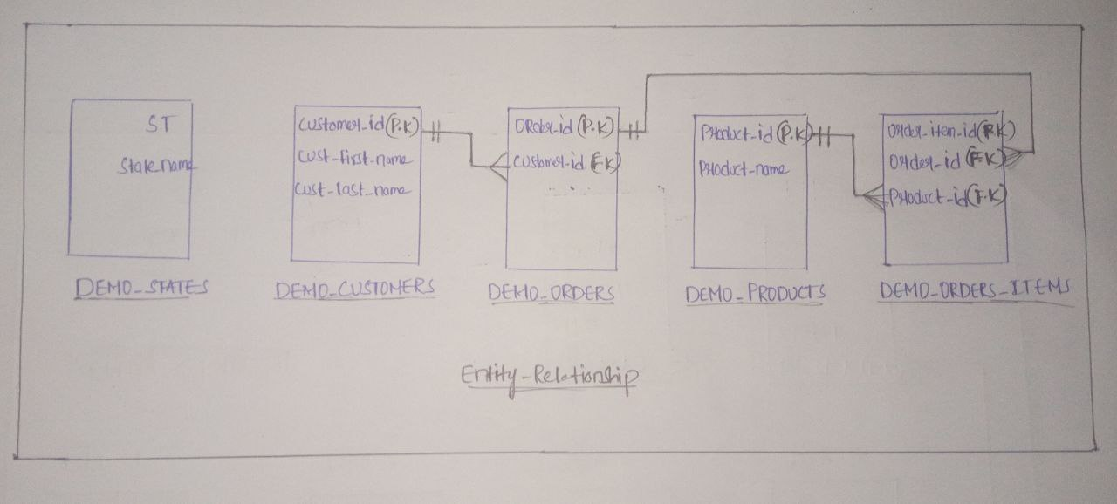

8.

select

distinct dp.category,

count(*) over(partition by dp.category) as category_count

from demo_products dp

order by 2 desc

fetch first 1 row only;

9.

select

distinct dp.category,

sum(quantity) over(partition by dp.category) as quantity_count

from demo_products dp

inner join demo_order_items doi on dp.product_id=doi.product_id

order by 2 desc

fetch first 1 row only;

10.

select

distinct dc.customer_id,

dp.product_id,

sum(doi.quantity)

from demo_customers dc

inner join demo_orders dor on dor.customer_id=dc.customer_id

inner join demo_order_items doi on dor.order_id=doi.order_id

inner join demo_products dp on dp.product_id=doi.product_id

group by rollup(dc.customer_id,dp.product_id);